Grade 7 Accelerated · Unit 4 · Lessons 2–3  Multiplying and Dividing in Scientific Notation  Question Bank 4.02 ANSWER KEY | Name  Date  Period

Show your work. Circle your final answer.
For questions 1 through 6, multiply or divide. Write each answer in scientific notation.
1. 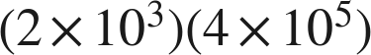


2. 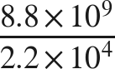


3. 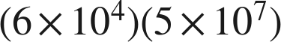

The coefficients multiply to 30, so the answer needs one more step.

4. 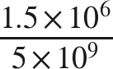

A coefficient below 1 is unfinished: point one place right, exponent down one.

5. 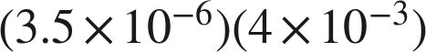

Both exponents are negative, so the product law adds them to −9.

6. 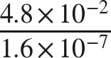

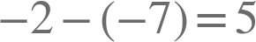.

Real quantities.
7. Three meteorites have masses 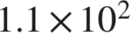, 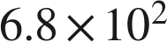 and 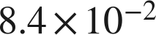 grams.
a. How many times as heavy as the lightest one is the heaviest one? Round to the nearest whole number.
about 8,095 times
b. How many times as heavy as the lightest one is the gram one? Round to the nearest whole number.
about 1,310 times

8. A data center processes about  records per hour.
a. How many records does it process in  hours?
 records
, so the product is  before it is finished.
b. A second center processed  records in 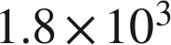 hours. How many records per hour is that?
 records per hour

Working backwards.
9. Find the missing number in each equation.
a.
n = 7
.
b. 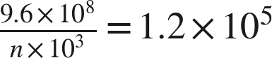
n = 8
.
c. 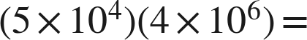 ______

The coefficients multiply to 20, so  becomes .

Reading someone else's work.
10. Tyree multiplies 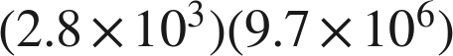 and writes . Is his value correct? Is his answer written in scientific notation? Write the finished answer.
The value is correct. It is not in scientific notation, because 27.16 is not less than 10. Finished: .
 and , so every step he took was right — he stopped one step early.

11. Which is the value of 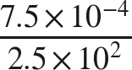 ?
○ A. 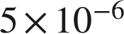
● B. 
○ C. 
○ D. 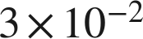
B

12. Select ALL of the expressions whose value is .
☒ A. 
☒ B. 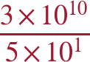
☒ C. 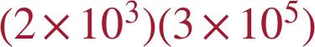
☐ D. 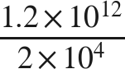
☐ E. 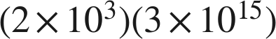
☒ F. 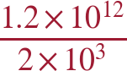
A, B, C and F
F and B each give , which is  once it is finished.

